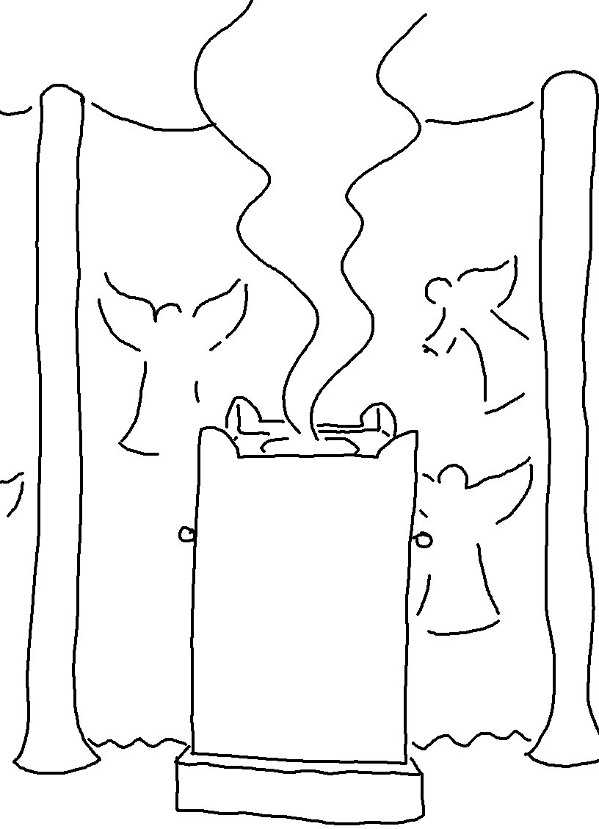
I was glad when they said to me, "Let us go to the _ _ _ _ _ of the_ _ _ _." Psalms 122:1_{NLT}

